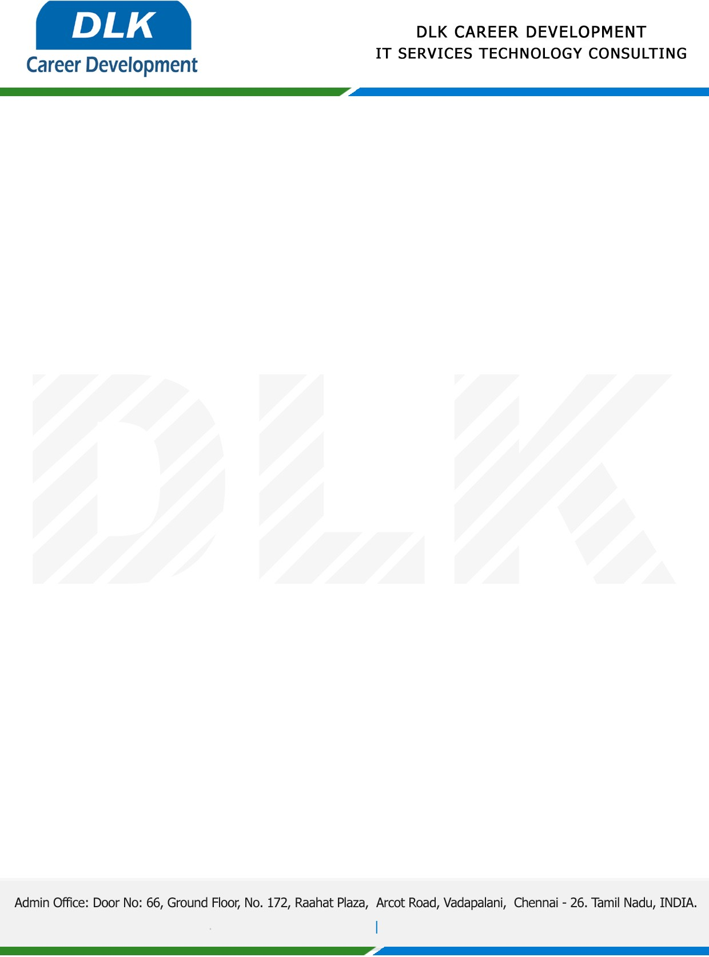

Date: 13 / February/ 2023

**To**

Department of BCA ( [Computer Application),](https://www.cseindia.org/)

Head of Department,

Alpha arts and science college, Chennai - 600116.

**Sub: Letter of Project Acceptance**

This is to certify that **MR CHANDRU S (REG NO: 212002738)** final year student of has accepted the Project Work duration from **15th** **February 2023** to **14th April 2023** under the domain **“Java”.** During the Project, all information and data collected from you should be kept confidential.

**Topic:** Prison Management System

We appreciate your interest in **DLK CAREER DEVELOPMENT**

